
Company
Logotype

Cone Beam Computed Tomography- Report



Porur Dental X-rays & CBCT

Patient Name : Mr. Munusamy | Date of Report : 06.05.2024
Age/ Gender : 53 years/ Male | Region of Interest : CBCT Full Skull
Referring doctor: Dr. Suchitra Mohan | Indication : Cyst in relation to right side of mandible
Clinical Notes: Nil
PATIENT INFORMATION

CBCT Full Skull provided
CBCT – IMAGE DETAILS

RADIOGRAPHIC INTERPRETATION

- Completely missing crown and root portion in relation to 26, 27, 28, 31, 37, 38, 46, 47, 48.
- In 46 region, presence of a single, diffuse, irregular hypodense depression bounded by an irregular margin measuring 21.17 x 8.57 x 11.66 mm in dimension.
- The hypodense region appears to be in proximity to the inferior alveolar nerve canal, appears to push the canal inferiorly.
- Distance between the hypodense area and inferior alveolar nerve canal in the anterior aspect: 2.23 mm, in the posterior aspect: 4.4 mm.

RADIOGRAPHIC IMPRESSION

- Differential Diagnosis (based on the visible radiological features): Pathological bone defect in relation to the right mandibular region.


Kindly correlate with clinical and histopathological features

IMAGES FOR REFERENCE

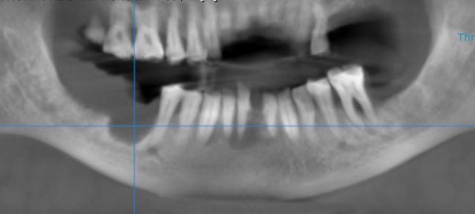
RECONSTRUCTED PANORAMIC VIEW
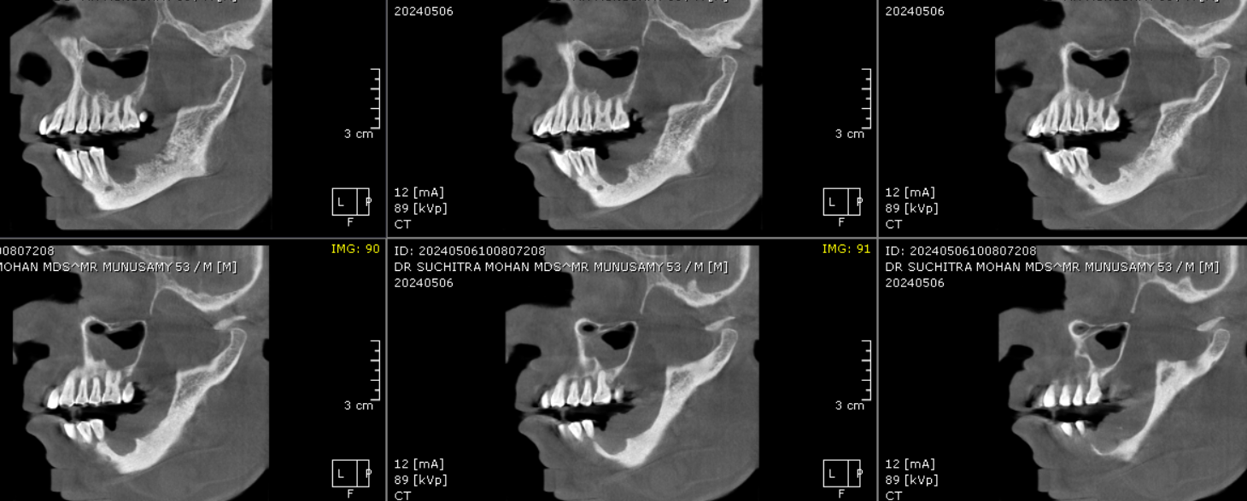
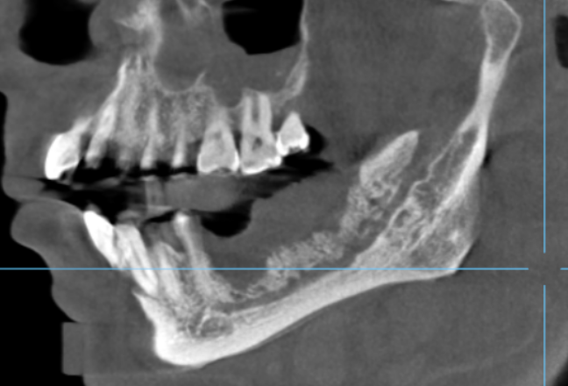
SAGITTAL IMAGES FOR REFERENCE

CROSS SECTIONAL IMAGES FOR REFERENCE
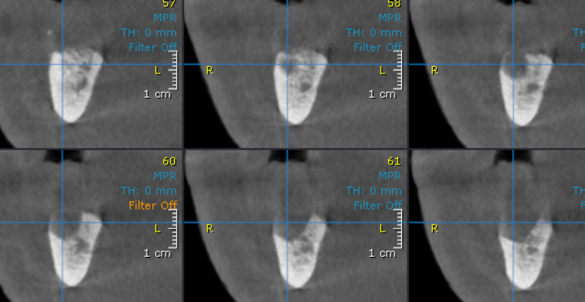

3-DIMENSIONAL VIEW

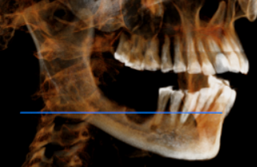

**** End of report ****

